People rest web app,

The Application Person test app allows to work on data in H2 db , these data are loaed when the application is started and deleted when the application si in shutdown.

To start the application open the command line console , go inside dist folder and digit the following command, the application needs that java 8 is installed on computer

Java -jar candidate-0.0.1-SNAPSHOT.jar

After launched the command the spring boot application will start

## Restful interfaces

### Person Interface

The operation allowed for person are typical for any rest service(post, put , get and delete)

In the following paragraphs, thew operation will be described

#### Data get Operations

These operations are called by http get method, in Person they are three operation.

Localhost:8080/person

It will return a list of people stored in db at moment.

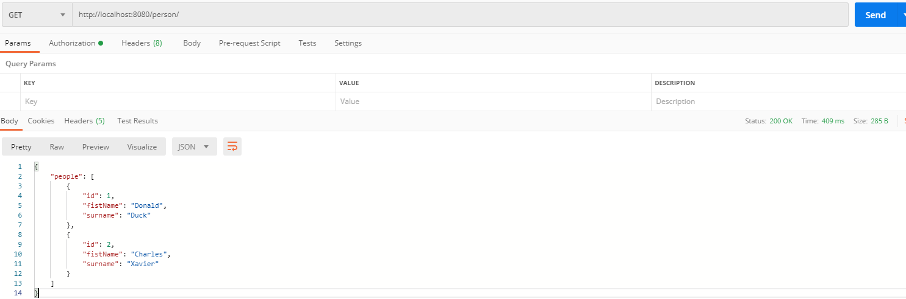

Localhost:8080/person/{personId}

It Will return the json object contains the person data associated to Id person in the url

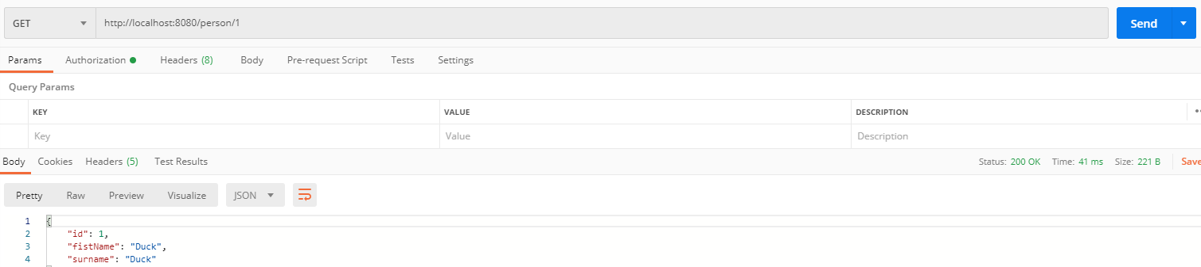

Localhost:8080/person/count

It will return the count of person table records stored in db

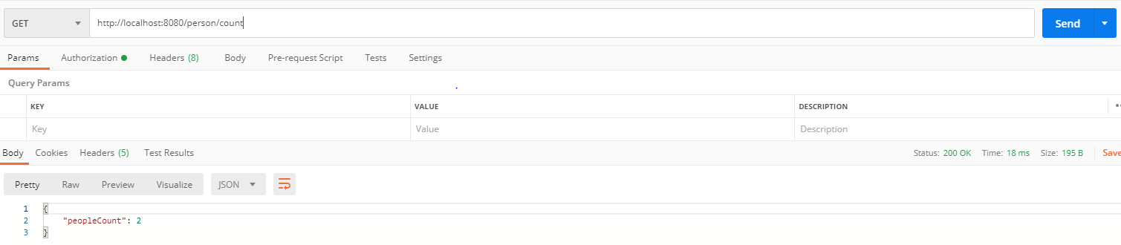

Data manipulation Operations

The data manipulation is made through the http methods.

POST

The data is inserted by following url submitted in POST

Localhost:8080/person

Sending the following json object

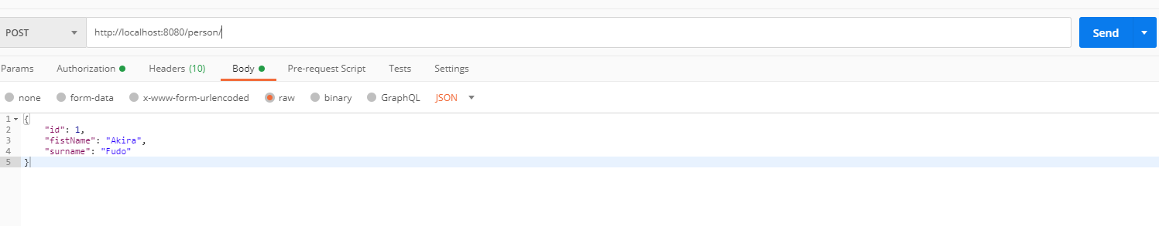

When the new person is added the server return 201 status(created)

PUT

The data is updated by following url submitted in Put

Localhost:8080/person/{personId}

Sending the following json object

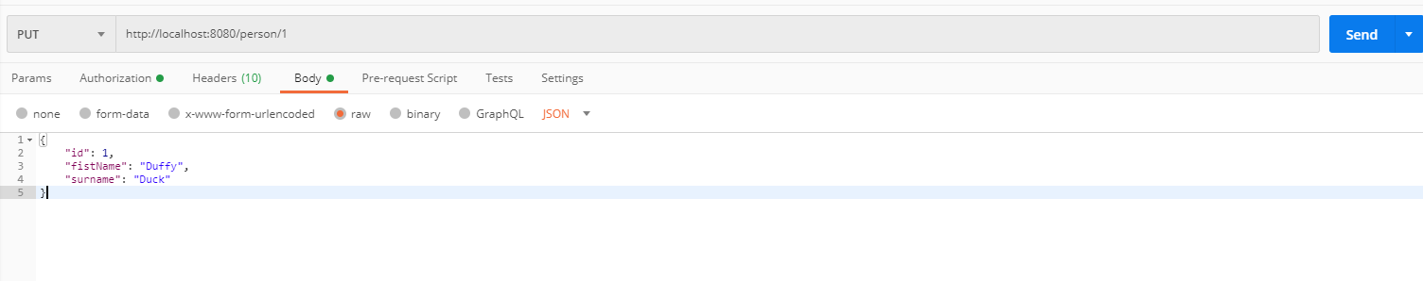

The record associated to person Id will updated with new data and the server returns http status 200(Ok poeration).

#### **Delete**

The Http delete method deletes the person by Id and all the addresses associated to it.

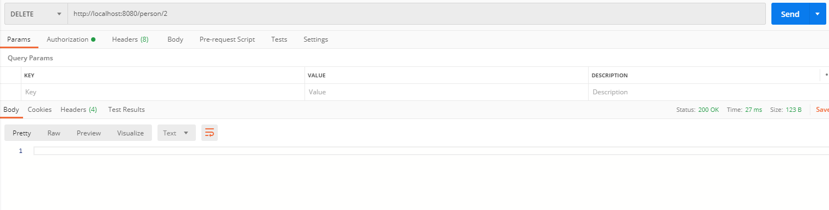

The server will return http status 200.

### Address interface

The service similarly to person manipulated and show the data fo the addresses related to the person

The url for access to the rest services is /person/{personId}/address/{addressId} and /person/{personId}/address that returns all the address for person id;

#### Data get Operations

These operations are called by http get method, in Address they are two operation.

Localhost:8080//person/{personId}

Wil return the list of all the addresses associated to person Id

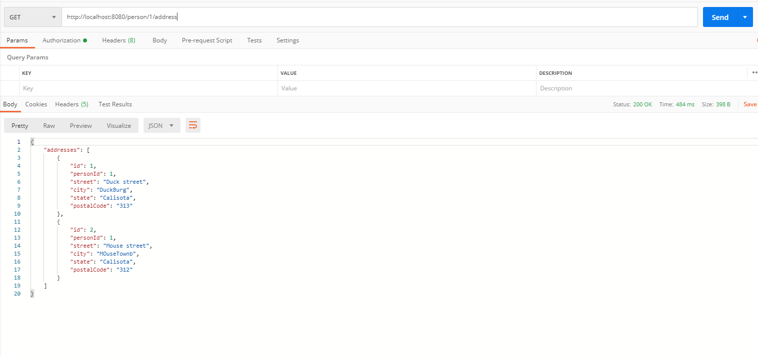

With the following url

http://localhost:8080/person/1/address/1

The server will return the json object associate to AddressId

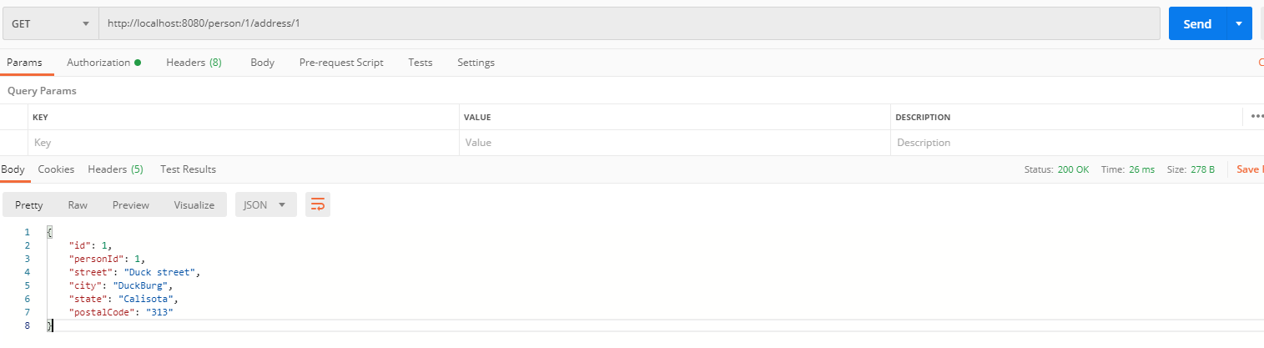

Data manipulation Operations

The data manipulation is made through the http methods.

Post

The data is inserted by following url submitted in POST

Localhost:8080/person/{personId}/address

It wiil insert a new address record associated to the person by id

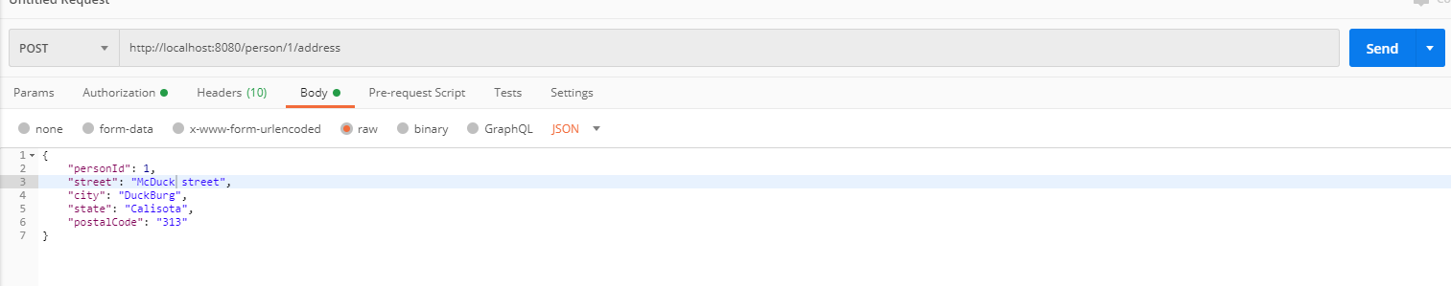

Put

PUT

The data is updated by following url submitted in Put

Localhost:8080/person/{personId}/address/{addressId}

Sending the following json object

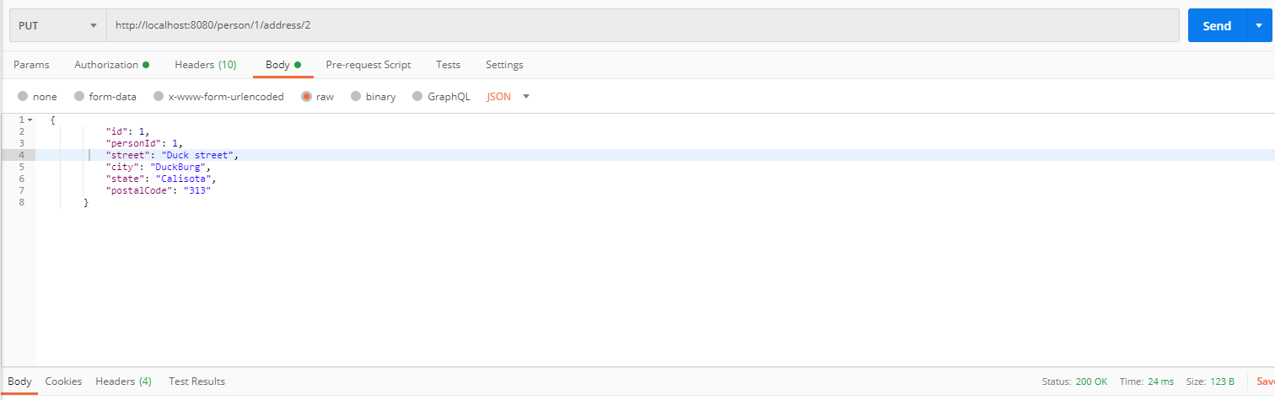

The server will update the Address and return http code 200

DELETE

It will delete the address record by address Id

Localhost:8080/person/{personId}/address/{addressId}

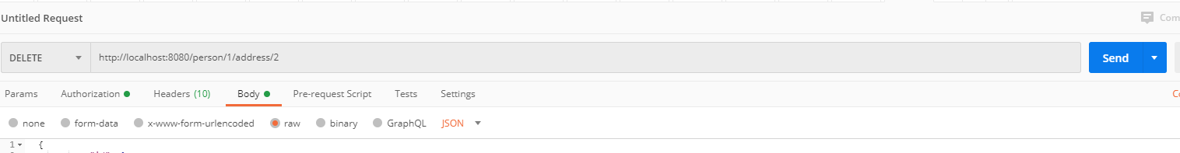

The server will return http code 200(Ok)

FOR DEVELOPER.

For compiler and generate a new compiled jar open a new command line and go to the root project, it’s mandatory to have Maven set in the computer.

Digit the the following command

mvn clean install

maven will create a new jar candidate-0.0.1-SNAPSHOT.jar in the target folder.